High-Frequency Vocabulary

📊 What is High-Frequency Vocabulary
# Source: Chatgpt (GPT-4-turbo) at [7/30/2025]
High-frequency vocabulary consists of words that appear very often in spoken and written language. These are the most commonly used and essential words in everyday communication and are usually learned early in language acquisition.

✅ Key Features:
# Source: Chatgpt (GPT-4-turbo) at [7/30/2025]
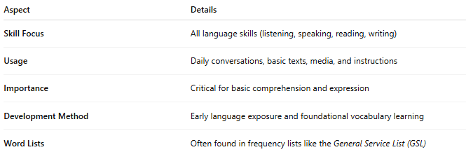
Aspect | Details
Skill Focus | All language skills (listening, speaking, reading, writing)
Usage | Daily conversations, basic texts, media, and instructions
Importance | Critical for basic comprehension and expression
Development Method | Early language exposure and foundational vocabulary learning
Word Lists | Often found in frequency lists like the General Service List (GSL)

🧠 Examples:
# Source: Chatgpt (GPT-4-turbo) at [7/30/2025]
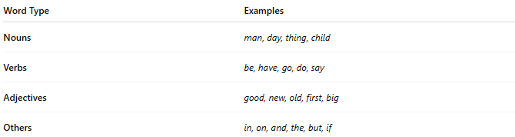
Word Type | Examples
Nouns | man, day, thing, child
Verbs | be, have, go, do, say
Adjectives | good, new, old, first, big
Others | in, on, and, the, but, if
📌 Words like “the,” “is,” “you,” and “and” are among the top 100 most frequent in English.

👤 Who Uses It?
# Source: Chatgpt (GPT-4-turbo) at [7/30/2025]
- Everyone, but especially:
  - Language learners building a core vocabulary
  - Children learning to read and speak
  - Educators and curriculum designers

📌 Related Vocabulary Types:
# Source: Chatgpt (GPT-4-turbo) at [7/30/2025]
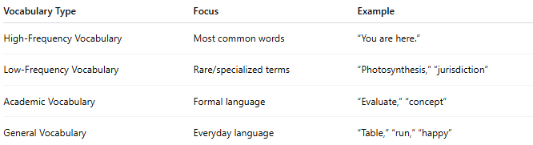
Vocabulary Type | Focus | Example
High-Frequency Vocabulary | Most common words | “You are here.”
Low-Frequency Vocabulary | Rare/specialized terms | “Photosynthesis,” “jurisdiction”
Academic Vocabulary | Formal language | “Evaluate,” “concept”
General Vocabulary | Everyday language | “Table,” “run,” “happy”

